Sub queries __ NON_CORRELATED

* Write an SQL command that will find any customers who have not placed orders.

SELECT CustomerID, CustomerName

FROM Customer_T

WHERE CustomerID NOT IN

(SELECT CustomerID FROM Order_T);

----- no need to use in, all, any IN THIS SUBQUERY. It’s a single row sub query

SELECT ProductDescription, ProductStandardPrice

FROM Product_T

WHERE ProductStandardPrice =

(SELECT MAX(ProductStandardPrice)

FROM Product_T);

*query below Returns to the outer query more than one row of results consisting of one column (i.e., a list of values

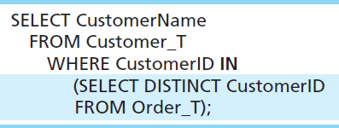

* Query below Returns to the outer query more than one column of results

SELECT ProductLineID, ProductDescription

FROM Product_T

WHERE (ProductLineID, ProductStandardPrice) IN

(SELECT ProductLineID, MAX(ProductStandardPrice)

FROM Product_T

GROUP BY ProductLineID);

SELECT ProductDescription, ProductStandardPrice

FROM Product_T

WHERE ProductStandardPrice **>ALL**

(SELECT ProductStandardPrice

FROM Product_T WHERE ProductLineID=1);

SELECT ProductDescription, ProductStandardPrice

FROM Product_T

WHERE ProductStandardPrice **<ANY**

(SELECT ProductStandardPrice

FROM Product_T WHERE ProductLineID=1);